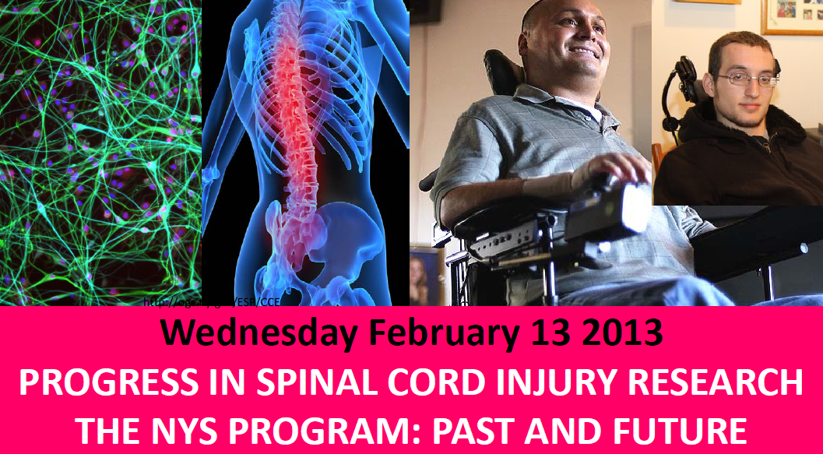
Fact Sheet
Spinal Cord Injury Research Program (SCIRP)

Key Impacts

- Biomedical Opportunity: Currently spinal cord treatments are decades old and rely on stabilization with no effective therapeutics. Therapeutics developed for spinal cord injury can be applied to traumatic brain injury and other nerve injuries and diseases. This is an open area for product development, desperately needed for domestic and military patients.

- Set NYS at the forefront of Spinal Cord Injury Research:
  - Researchers at the Wadsworth Center in Albany led by Dr. Jonathan Wolpaw, developed a spinal nerve retraining technique that is now in clinical use to improve walking deficits.
  - Drs. Jason Carmel and Jack Martin at CUNY showed that electrical stimulation is beneficial for spinal cord injury, now adopted in labs around the world and moving into clinical use.
  - University of Rochester Medical Center researchers found that the compound Brilliant Blue G (BBG) – a common food additive used in M&Ms and Gatorade – can partially cure paralysis in rats with spinal cord injuries, a finding that is being moved toward clinical trials.
  - A team of researchers led by Dr. Sally Temple, the Neural Stem Cell Institute, Rensselaer NY, Albany Medical College and Rensselaer Polytechnic Institute developed a novel Biomaterial releasing growth factor that significantly improved recovery after spinal cord injury in animal models. Further research is needed to bring this exciting finding to the point of a clinical trial.

- Attracts Additional Investment to NYS Projects: Most SCIRP funding recipients have used the results of their scientific work to apply for additional funding from the federal government (including the National Institute of Health (NIH) and private foundations. According to a recent survey of recipients who collectively received $13.8 million from SCIRP, their projects successfully leveraged $22.7 million in outside grants, implying a more than three-to-two multiplier of leveraged outside funds to state SCIRP funds.

- High-Tech Job Creation: The $54 million awarded through SCIRP since it began in 1998 and the millions of additional leveraged dollars support hundreds of high-tech jobs in New York State, including scientists and support staff in universities, hospitals and research institutions. According to the survey referenced above, $13.8 million in SCIRP funds and $22.7 million in leveraged funds supported 160 jobs, attracted 41 individuals from out of state and generated eight patents.

- Integral Part of State’s Economic Development Efforts: SCIRP established and continues to fund the Spinal Cord Injury Center of Research Excellence (SCI CORE), a first-in-the-nation collaboration between research and rehabilitation institutes from around the state seeking to discover and deliver new treatments for spinal cord injury. The central CORE facility is the Burke-Cornell Medical Research Institute (White Plains) and participating institutions include: Weill Cornell Medical College (New York City), University of Rochester Medical Center, Columbia University, Hunter College, Helen Hayes Hospital (West Haverstraw) and Acorda Therapeutics Inc (Hawthorne).

- Helping to Develop NY’s Biotechnology Industry: Acorda Therapeutics, located in Westchester County, received FDA approval in January 2013 for a new pharmaceutical product to treat multiple sclerosis. As a member of the Spinal Cord Injury Center of Research Excellence (SCI CORE), Acorda is just one example of the New York State based biotech companies that SCIRP funding can help grow.

- Widespread Regional Beneficiaries: Recipients of SCIRP funding have included: University at Buffalo, Stony Brook University, Albany Medical College, University at Albany, RPI, SUNY Upstate Medical University, NY Medical College, SUNY Downstate Medical Center, NYU Medical Center, NYU School of Medicine, Sloan Kettering, Mt. Sinai School of Medicine, College of Staten Island (CUNY)

Background

- On September 30, 1973, New York State Police Zone Sergeant Paul Richter was shot three times during a traffic stop. One of those bullets damaged Sgt. Richter’s spinal cord, paralyzing him from the neck down. Although he eventually regained enough function to walk with a cane, Sgt. Richter had to retire from the State Police.

- Sgt. Richter conceived the idea of a state spinal cord injury research program funded by a surcharge on motor vehicle violations. After unanimous passage in the State Senate and Assembly, Governor Pataki signed the enacting legislation on July 14, 1998 at NYU Medical Center. The late Christopher Reeve attended the bill signing.

- The bill established the Spinal Cord Injury Research Trust Fund and designated up to $8.5 million per year (generated by a surcharge on fines for moving violations) to assist leading researchers with ongoing and new efforts to find a cure for spinal cord injuries.

- The bill created the New York State Spinal Cord Injury Research Board (SCIRB), consisting of 13 members appointed by the Governor and legislative leaders, to administer a research grants program financed by the Spinal Cord Injury Research Trust Fund.

- The bill and success of the program inspired other states to create similar programs, e.g. the Roman Reed Act in California.

- The 2010-11 Executive Budget proposed to terminate the SCIRB (the Spinal Cord Injury Research Board) as of April 1, 2010 and end the program, so that no new awards will be made (awards worth $6.7 million in FY 2010-11) as part of a $14 million effort to save money on “low priority” health programs. The budget noted that existing awards will continue to be honored.

- Since then, the surcharge continues to be collected, but is no longer used to support the NYS spinal cord injury research programs. Rather, those funds have been directed to the NYS General Fund. The estimated amount collected annually via the motor vehicle surcharge on moving violations is about $150 million We ask that the spinal cord injury research funding of up to $8.5 million is reinstated to serve the original intent of the legislation.
- As of today, there is one remaining SCRIB contract (awarded in November, 2009) to the Weill Medical College of Cornell University in NYC. This contract, for a total of $2.5 million, will expire on Dec. 31, 2013. It is estimated that there will be less than $800,000 left in the SCIRB Trust Fund at that time.
###
MEDIA CONTACTS:
Kathy Condon Cindy Butler
Condon Communications Event Coordinator
PH: 518-436-1103 Neural Stem Cell Institute
CELL: 518-441-0259 Phone: 518-694-8188
condonkathy@gmail.com cindybutler@nynsci.org

